SOFTWARE TESTING – TEST REPORT
Practical 13: Selenium Environment Setup and Verification
1. Test Report Information
Project Name | Selenium Environment Setup
Practical | Practical 13 – Tutorial 13
Application Under Test | Selenium Official Website (https://www.selenium.dev/)
Module Tested | Environment Configuration
Test Type | Automated system test (black box)
Automation Script | P13.py
Executed By | Anil kumar
Execution Date | 02-10-2026 (started 10:31:29)
Overall Result | PASS (12 of 12 test cases passed)
2. Aim
To create and configure Python, Selenium WebDriver, the PyCharm IDE, a browser driver and automation testing libraries for Selenium testing, and to verify the configuration by running a Selenium program that launches Chrome and opens a web page.
3. Application Under Test
The application used for verification is the official Selenium website. It was used as a stable public web page to confirm that the Selenium environment can launch a browser, load a page, read the page title and URL, and perform basic navigation.
4. Test Environment
Parameter | Details
Operating System | Windows
Programming Language | Python 3.14.3
Automation Library | Selenium 4.49.0
Browser | Google Chrome 154.0.8037.58
WebDriver | ChromeDriver 154.0.8037.92
IDE | PyCharm
Test URLs | https://www.selenium.dev/  https://www.selenium.dev/documentation/
5. Test Scenarios
Area | Scenarios | Test IDs
Environment | Python and Selenium library available | TC-13-01
Browser launch | Launch Chrome through WebDriver, maximize window | TC-13-02, 03
Page load | Open website, verify title, URL and content | TC-13-04 to 07
Browser navigation | Documentation page, back, forward, refresh | TC-13-08 to 11
Browser close | Close browser and end WebDriver session | TC-13-12
6. Test Execution
Results below are taken from the actual console output of P13.py.
Test ID | Scenario | Expected Result | Actual Result | Status
TC-13-01 | Python and Selenium library available | Python 3 and Selenium import without errors | Python 3.14.3, Selenium 4.49.0 imported successfully | PASS
TC-13-02 | Launch Chrome using Selenium WebDriver | Chrome launches and a WebDriver session is created | Browser = chrome 154.0.8037.58, ChromeDriver = 154.0.8037.92, session created | PASS
TC-13-03 | Maximize browser window | Window maximizes with valid size | Window size = 1178 x 640 | PASS
TC-13-04 | Open Selenium website | Website opens and page finishes loading | Opened https://www.selenium.dev/, document.readyState = complete | PASS
TC-13-05 | Verify page title | Title contains "Selenium" | Page Title = 'Selenium' | PASS
TC-13-06 | Verify current URL | URL is https://www.selenium.dev/ | Current URL = https://www.selenium.dev/ | PASS
TC-13-07 | Verify page content loaded | Page body has content and links | Page body has content, 53 links found | PASS
TC-13-08 | Navigate to Documentation page | Documentation page opens | URL = https://www.selenium.dev/documentation/, title = 'The Selenium Browser Automation Project | Selenium' | PASS
TC-13-09 | Browser back navigation | Home page opens | back() -> https://www.selenium.dev/ | PASS
TC-13-10 | Browser forward navigation | Documentation page opens | forward() -> https://www.selenium.dev/documentation/ | PASS
TC-13-11 | Browser refresh | Same page reloads with same URL | refresh() kept URL = https://www.selenium.dev/documentation/ | PASS
TC-13-12 | Close browser | Browser closes and session ends | Browser closed; WebDriver session ended | PASS
7. Execution Summary
Metric | Value
Total Test Cases Executed | 12
Passed | 12
Failed | 0
Pass Percentage | 100%
Execution Time | 21.69 seconds
Overall Status | PASS
8. Observations
Sr. No. | Observation
1 | The Selenium environment (Python 3.14.3, Selenium 4.49.0, Chrome and ChromeDriver) was configured correctly; the script ran in PyCharm and finished with exit code 0.
2 | Chrome 154.0.8037.58 was launched through Selenium using ChromeDriver 154.0.8037.92.
3 | The website loaded completely; the title was "Selenium" and the URL was https://www.selenium.dev/.
4 | The home page had visible content and 53 links.
5 | The Documentation page opened with the title "The Selenium Browser Automation Project | Selenium". Back, forward and refresh behaved as expected.
6 | The browser closed cleanly and the WebDriver session ended. No failures or exceptions occurred.
7 | The title of the home page ("Selenium") differs from the title of the documentation page, so the check was written to look for the word "Selenium" in the title instead of an exact full title.
9. Evidence
Insert the screenshots below before submission.
Figure 1: PyCharm project
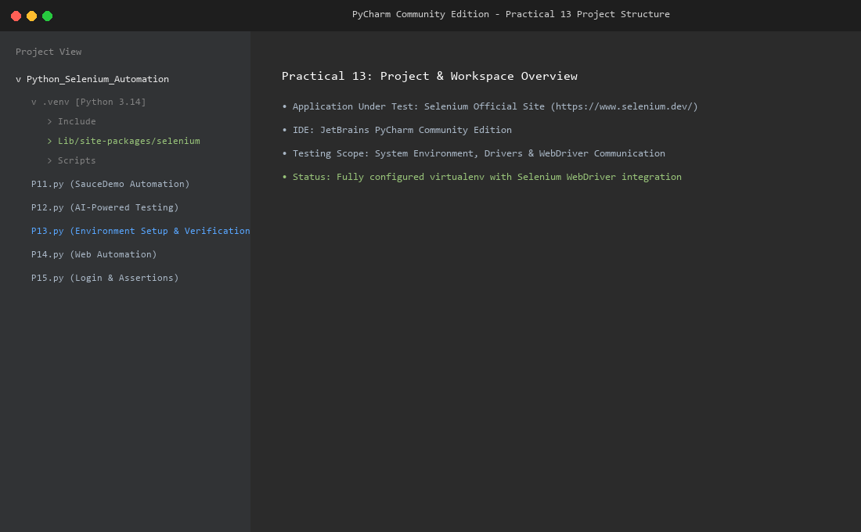
Figure 2: Python interpreter
Figure 3: Selenium installation (pip install / pip show selenium)
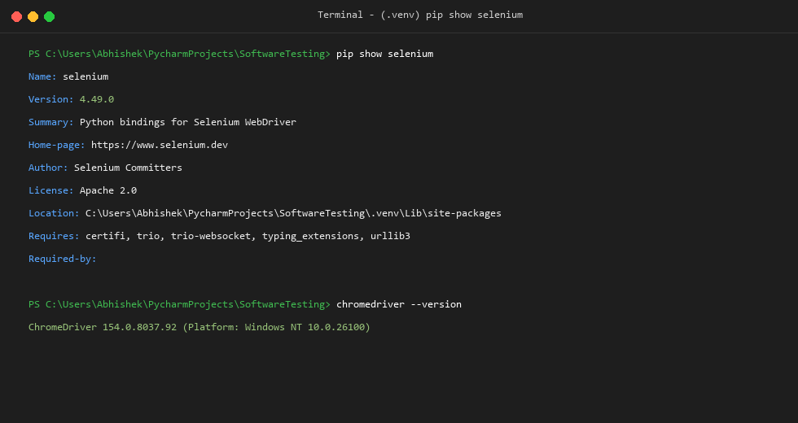
Figure 4: Source code in PyCharm
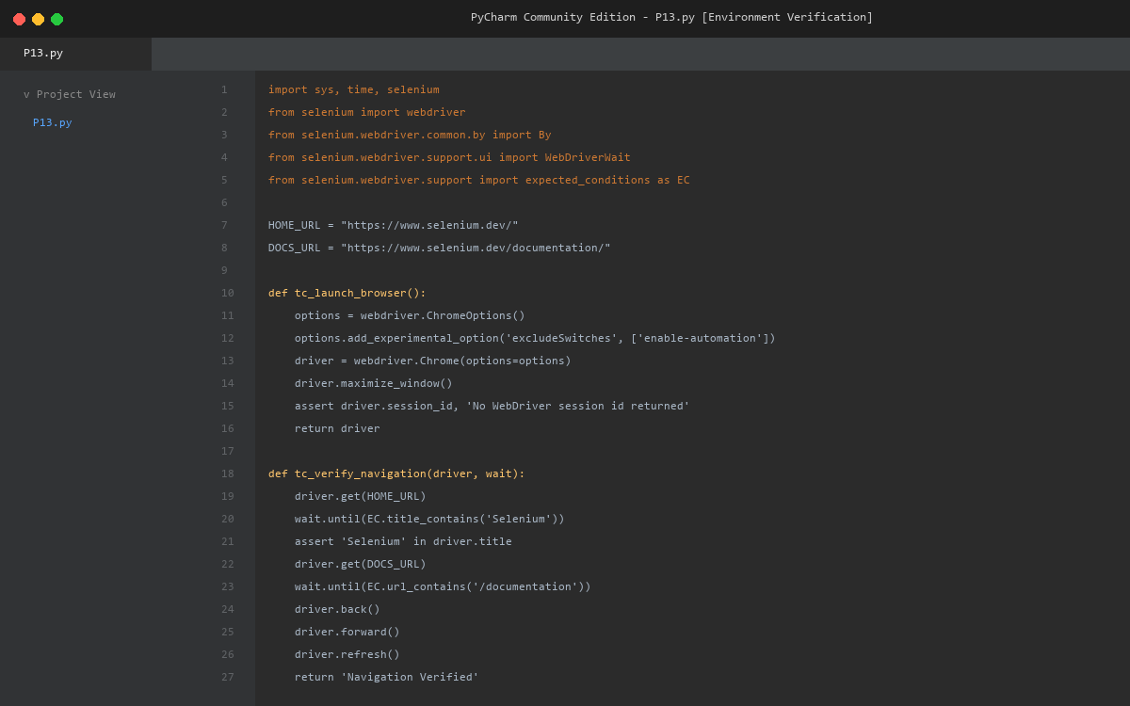
Figure 5: Chrome browser opened by Selenium
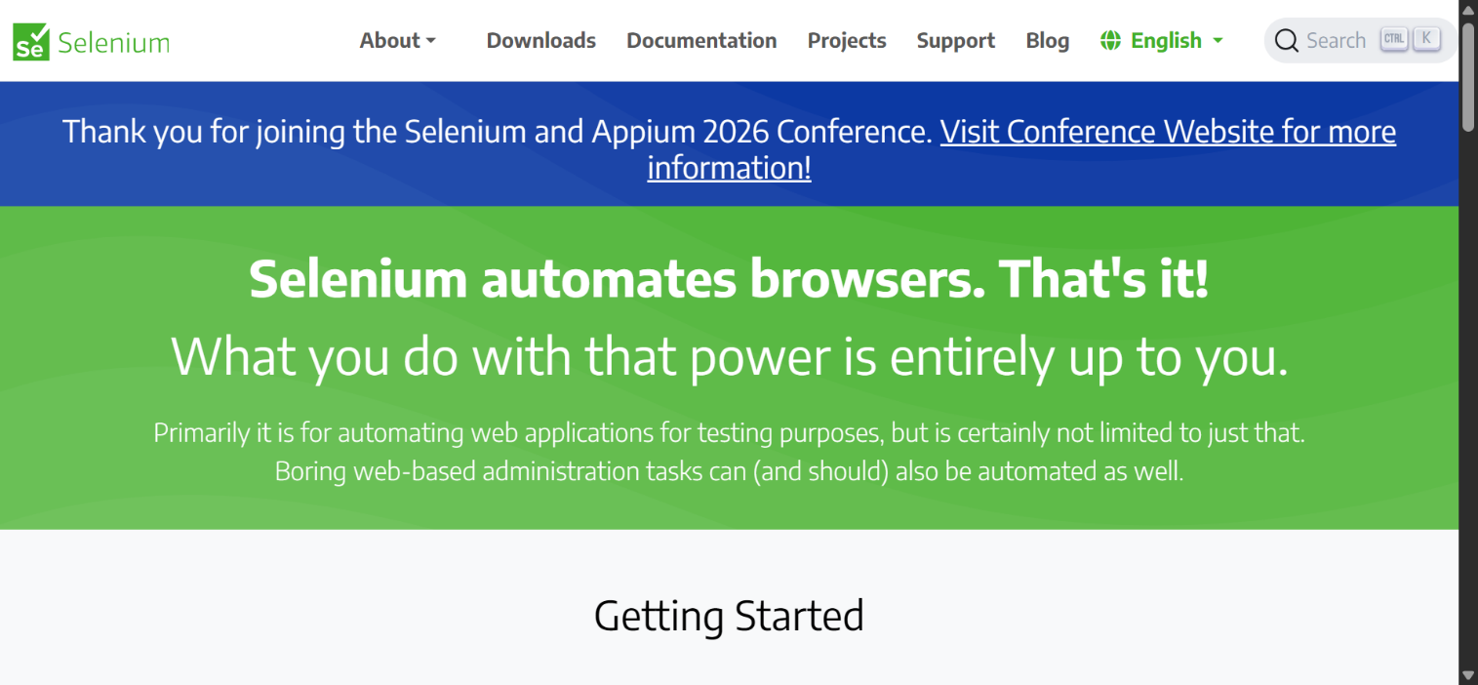
Appendix A: Console Output
======================================================================
Practical 13 - Selenium Environment Setup (selenium.dev)
Execution started: 02-10-2026 10:31:29
======================================================================

--- TC-13-01: Python and Selenium library available ---
Result : PASS
Detail : Python 3.14.3, Selenium 4.49.0 imported successfully

--- TC-13-02: Launch Chrome using Selenium WebDriver ---
Result : PASS
Detail : Browser = chrome 154.0.8037.58, ChromeDriver = 154.0.8037.92, session created

--- TC-13-03: Maximize browser window ---
Result : PASS
Detail : Window size = 1178 x 640

--- TC-13-04: Open Selenium website ---
Result : PASS
Detail : Opened https://www.selenium.dev/, document.readyState = complete

--- TC-13-05: Verify page title ---
Result : PASS
Detail : Page Title = 'Selenium'

--- TC-13-06: Verify current URL ---
Result : PASS
Detail : Current URL = https://www.selenium.dev/

--- TC-13-07: Verify page content loaded ---
Result : PASS
Detail : Page body has content, 53 links found

--- TC-13-08: Navigate to Documentation page ---
Result : PASS
Detail : URL = https://www.selenium.dev/documentation/, title = 'The Selenium Browser Automation Project | Selenium'

--- TC-13-09: Browser back navigation ---
Result : PASS
Detail : back() -> https://www.selenium.dev/

--- TC-13-10: Browser forward navigation ---
Result : PASS
Detail : forward() -> https://www.selenium.dev/documentation/

--- TC-13-11: Browser refresh ---
Result : PASS
Detail : refresh() kept URL = https://www.selenium.dev/documentation/

--- TC-13-12: Close browser ---
Result : PASS
Detail : Browser closed; WebDriver session ended

======================================================================
EXECUTION SUMMARY
======================================================================
TC-13-01 Python and Selenium library available PASS
TC-13-02 Launch Chrome using Selenium WebDriver PASS
TC-13-03 Maximize browser window PASS
TC-13-04 Open Selenium website PASS
TC-13-05 Verify page title PASS
TC-13-06 Verify current URL PASS
TC-13-07 Verify page content loaded PASS
TC-13-08 Navigate to Documentation page PASS
TC-13-09 Browser back navigation PASS
TC-13-10 Browser forward navigation PASS
TC-13-11 Browser refresh PASS
TC-13-12 Close browser PASS
----------------------------------------------------------------------
Total test cases executed : 12
Passed : 12
Failed : 0
Execution time : 21.69 seconds
Overall status : PASS
======================================================================
Appendix B: Source Code (P13.py)
"""
Practical 13 - Selenium Environment Setup (Software Testing)
Application Under Test : Selenium Official Website (https://www.selenium.dev/)
Tool / Language : Selenium WebDriver + Python (Google Chrome, PyCharm)

Purpose: verify that the Selenium automation environment (Python, Selenium
library, Chrome browser and WebDriver, PyCharm) is configured correctly by
launching Chrome, opening the Selenium website, checking the page title and
URL, performing basic browser navigation and closing the browser.

Install : pip install selenium
Verify : pip show selenium
Run : python PR13.py
"""

import sys
import time
from datetime import datetime

import selenium
from selenium import webdriver
from selenium.common.exceptions import (
NoSuchElementException,
TimeoutException,
WebDriverException,
)
from selenium.webdriver.common.by import By
from selenium.webdriver.support import expected_conditions as EC
from selenium.webdriver.support.ui import WebDriverWait

# --------------------------------------------------------------------------
# Test data
# --------------------------------------------------------------------------
HOME_URL = "https://www.selenium.dev/"
DOCS_URL = "https://www.selenium.dev/documentation/"
EXPECTED_TITLE_TEXT = "Selenium"

# --------------------------------------------------------------------------
# Shared state and result tracking
# --------------------------------------------------------------------------
ctx = {"driver": None, "wait": None, "session_id": None}
results = [] # (test_id, scenario, status, detail)

def run_test(test_id, scenario, func):
"""Execute one test, handle exceptions, print and record the outcome."""
print(f"\n--- {test_id}: {scenario} ---")
try:
detail = func()
status = "PASS"
except AssertionError as err:
status, detail = "FAIL", f"Assertion failed: {err}"
except TimeoutException:
status, detail = "FAIL", "TimeoutException: expected element/condition not found in time"
except NoSuchElementException as err:
status, detail = "FAIL", f"NoSuchElementException: {err.msg}"
except WebDriverException as err:
status, detail = "FAIL", f"WebDriverException: {str(err).splitlines()[0]}"
except Exception as err: # unexpected problems should still be reported, not crash the run
status, detail = "FAIL", f"{type(err).__name__}: {str(err).splitlines()[0] if str(err) else ''}"

results.append((test_id, scenario, status, detail))
print(f"Result : {status}")
print(f"Detail : {detail}")
return status == "PASS"

def need_driver():
assert ctx["driver"] is not None, "Browser was not launched (TC-13-02 must pass first)"
return ctx["driver"], ctx["wait"]

# --------------------------------------------------------------------------
# Test cases
# --------------------------------------------------------------------------
def tc_python_selenium_available():
major, minor = sys.version_info[:2]
assert major >= 3, f"Python 3 required, found {sys.version.split()[0]}"
version = selenium.__version__
assert version, "Selenium version could not be read"
return f"Python {sys.version.split()[0]}, Selenium {version} imported successfully"

def tc_launch_browser():
options = webdriver.ChromeOptions()
options.add_experimental_option("excludeSwitches", ["enable-automation"])
driver = webdriver.Chrome(options=options)
ctx["driver"] = driver
ctx["wait"] = WebDriverWait(driver, 20)
driver.set_page_load_timeout(60)

caps = driver.capabilities
browser_name = caps.get("browserName")
browser_version = caps.get("browserVersion")
driver_version = caps.get("chrome", {}).get("chromedriverVersion", "n/a").split(" ")[0]
ctx["session_id"] = driver.session_id
assert driver.session_id, "No WebDriver session id returned"
assert browser_name == "chrome", f"Unexpected browser: {browser_name}"
return (f"Browser = {browser_name} {browser_version}, ChromeDriver = {driver_version}, "
f"session created")

def tc_maximize_window():
driver, _ = need_driver()
driver.maximize_window()
size = driver.get_window_size()
assert size["width"] > 0 and size["height"] > 0, f"Invalid window size: {size}"
return f"Window size = {size['width']} x {size['height']}"

def tc_open_website():
driver, wait = need_driver()
driver.get(HOME_URL)
wait.until(lambda d: d.execute_script("return document.readyState") == "complete")
state = driver.execute_script("return document.readyState")
assert state == "complete", f"Page state: {state}"
return f"Opened {HOME_URL}, document.readyState = {state}"

def tc_verify_title():
driver, wait = need_driver()
wait.until(EC.title_contains(EXPECTED_TITLE_TEXT))
title = driver.title
assert EXPECTED_TITLE_TEXT in title, f"Title '{title}' does not contain '{EXPECTED_TITLE_TEXT}'"
return f"Page Title = '{title}'"

def tc_verify_url():
driver, wait = need_driver()
wait.until(EC.url_contains("selenium.dev"))
url = driver.current_url
assert url.startswith(HOME_URL), f"Unexpected URL: {url}"
return f"Current URL = {url}"

def tc_verify_page_content():
driver, wait = need_driver()
body = wait.until(EC.presence_of_element_located((By.TAG_NAME, "body")))
assert body.text.strip(), "Page body is empty"
links = driver.find_elements(By.TAG_NAME, "a")
assert len(links) > 0, "No links found on the page"
return f"Page body has content, {len(links)} links found"

def tc_navigate_to_documentation():
driver, wait = need_driver()
driver.get(DOCS_URL)
wait.until(EC.url_contains("/documentation"))
assert "/documentation" in driver.current_url, f"Unexpected URL: {driver.current_url}"
return f"URL = {driver.current_url}, title = '{driver.title}'"

def tc_browser_back():
driver, wait = need_driver()
driver.back()
wait.until(lambda d: d.current_url.rstrip("/") == HOME_URL.rstrip("/"))
assert driver.current_url.rstrip("/") == HOME_URL.rstrip("/"), f"Unexpected URL: {driver.current_url}"
return f"back() -> {driver.current_url}"

def tc_browser_forward():
driver, wait = need_driver()
driver.forward()
wait.until(EC.url_contains("/documentation"))
assert "/documentation" in driver.current_url, f"Unexpected URL: {driver.current_url}"
return f"forward() -> {driver.current_url}"

def tc_browser_refresh():
driver, wait = need_driver()
before = driver.current_url
driver.refresh()
wait.until(lambda d: d.execute_script("return document.readyState") == "complete")
assert driver.current_url == before, f"URL changed after refresh: {driver.current_url}"
return f"refresh() kept URL = {driver.current_url}"

def tc_close_browser():
driver, _ = need_driver()
driver.quit()
ctx["driver"] = None
# After quit() the WebDriver session must no longer respond
try:
driver.current_url
except Exception:
return "Browser closed; WebDriver session ended"
raise AssertionError("WebDriver session still responds after quit()")

# --------------------------------------------------------------------------
# Reporting
# --------------------------------------------------------------------------
def print_summary(elapsed):
total = len(results)
passed = sum(1 for r in results if r[2] == "PASS")
failed = total - passed
print("\n" + "=" * 70)
print("EXECUTION SUMMARY")
print("=" * 70)
for test_id, scenario, status, _ in results:
print(f"{test_id:<10} {scenario:<50} {status}")
print("-" * 70)
print(f"Total test cases executed : {total}")
print(f"Passed : {passed}")
print(f"Failed : {failed}")
print(f"Execution time : {elapsed:.2f} seconds")
print(f"Overall status : {'PASS' if failed == 0 and total > 0 else 'FAIL'}")
print("=" * 70)

def main():
print("=" * 70)
print("Practical 13 - Selenium Environment Setup (selenium.dev)")
print(f"Execution started: {datetime.now():%d-%m-%Y %H:%M:%S}")
print("=" * 70)

start = time.time()
try:
run_test("TC-13-01", "Python and Selenium library available", tc_python_selenium_available)
launched = run_test("TC-13-02", "Launch Chrome using Selenium WebDriver", tc_launch_browser)
if launched:
run_test("TC-13-03", "Maximize browser window", tc_maximize_window)
run_test("TC-13-04", "Open Selenium website", tc_open_website)
run_test("TC-13-05", "Verify page title", tc_verify_title)
run_test("TC-13-06", "Verify current URL", tc_verify_url)
run_test("TC-13-07", "Verify page content loaded", tc_verify_page_content)
run_test("TC-13-08", "Navigate to Documentation page", tc_navigate_to_documentation)
run_test("TC-13-09", "Browser back navigation", tc_browser_back)
run_test("TC-13-10", "Browser forward navigation", tc_browser_forward)
run_test("TC-13-11", "Browser refresh", tc_browser_refresh)
run_test("TC-13-12", "Close browser", tc_close_browser)
else:
print("\nBrowser could not be launched, remaining tests were not executed.")
finally:
if ctx["driver"] is not None:
ctx["driver"].quit()
print_summary(time.time() - start)

if __name__ == "__main__":
main()

